# Step to set up AWS microservices application
Step 1 → Create VPC + subnets
Step 2 → Internet Gateway + NAT
Step 3 → Route tables
Step 4 → Security Groups
Step 5 → Create ECR repos
Step 6 → Create ECS cluster
Step 7 → Create RDS PostgreSQL
Step 8 → Create Redis
Step 9 → Create S3 bucket
Step 10 → Create CloudWatch logs
Step 11 → ECS task definitions
Step 12 → ECS services
Step 13 → Application Load Balancer
Step 14 → Route53 + ACM
Step 15 → Autoscaling
Step 16 → Secrets Manager
Step 17 → CI/CD
Step 18 → Validation & troubleshooting

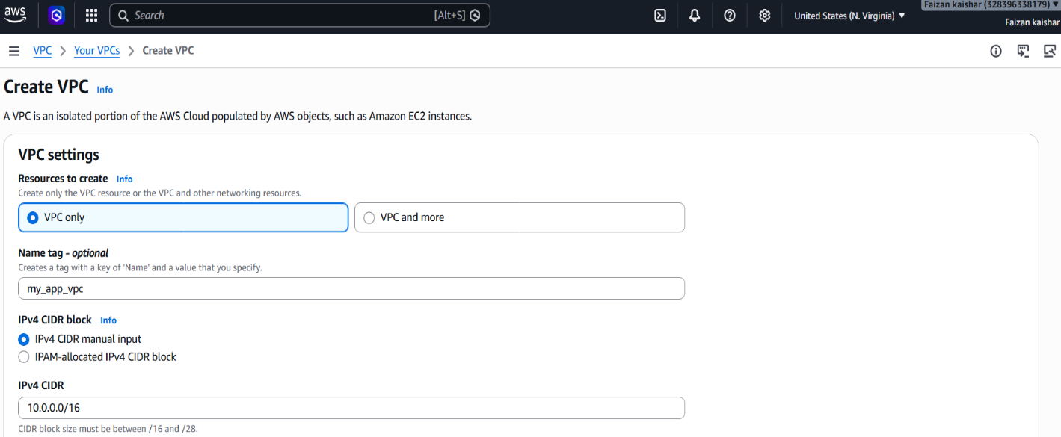
Step 1 → Create VPC + subnets

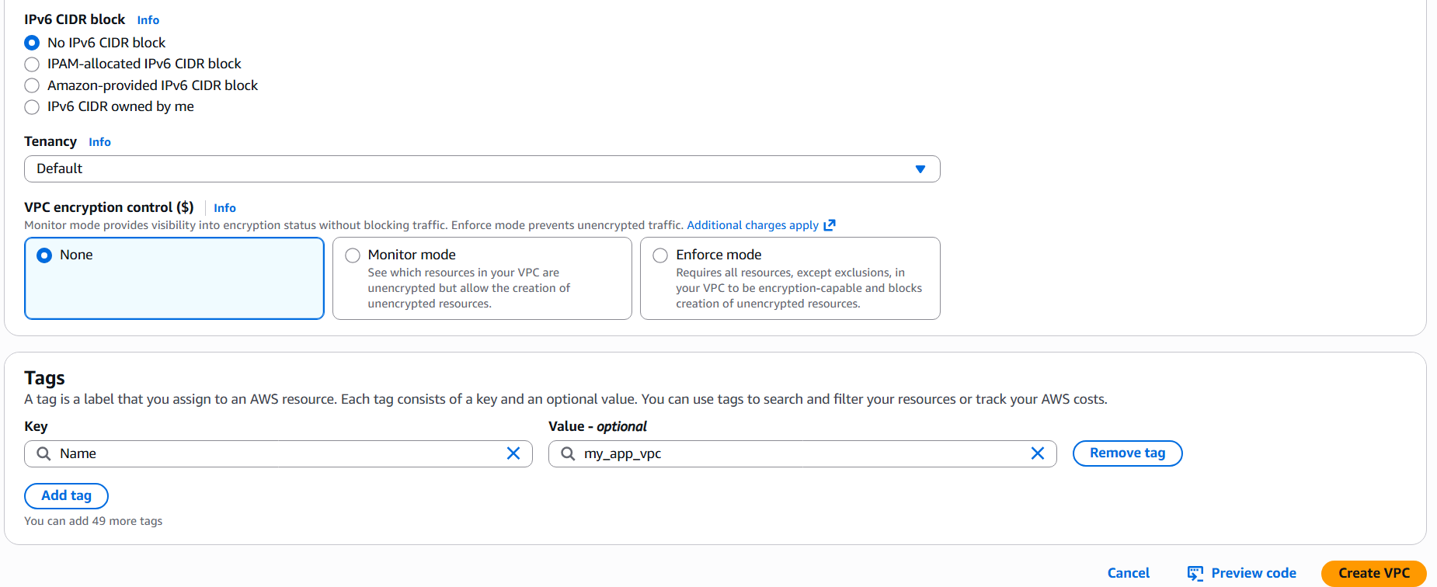

Open VPC Console → Create VPC→ Resources to create → VPC only → Name tag: microservices-vpc →IPv4 CIDR block: 10.0.0.0/16 → IPv6: None → Tenancy: Default →Click Create VPC

For this architecture, you need a VPC with 2 Public subnets + 2 Private App subnets + 2 Private DB subnets across 2 Availability Zones.

Step 2 → Create Subnets
Component | CIDR | AZ
VPC | 10.0.0.0/16 | -
Public Subnet A | 10.0.1.0/24 | ap-south-1a
Public Subnet B | 10.0.2.0/24 | ap-south-1b
Private App A | 10.0.11.0/24 | ap-south-1a
Private App B | 10.0.12.0/24 | ap-south-1b
Private DB A | 10.0.20.0/24 | ap-south-1a
Private DB B | 10.0.21.0/24 | ap-south-1b

→ Create Public Subnet A
Steps:
Subnets → Create subnet → Select VPC: microservices-vpc → Name: public-subnet-a → AZ: ap-south-1a → IPv4 CIDR: 10.0.1.0/24 → Create
Same for all Subnets

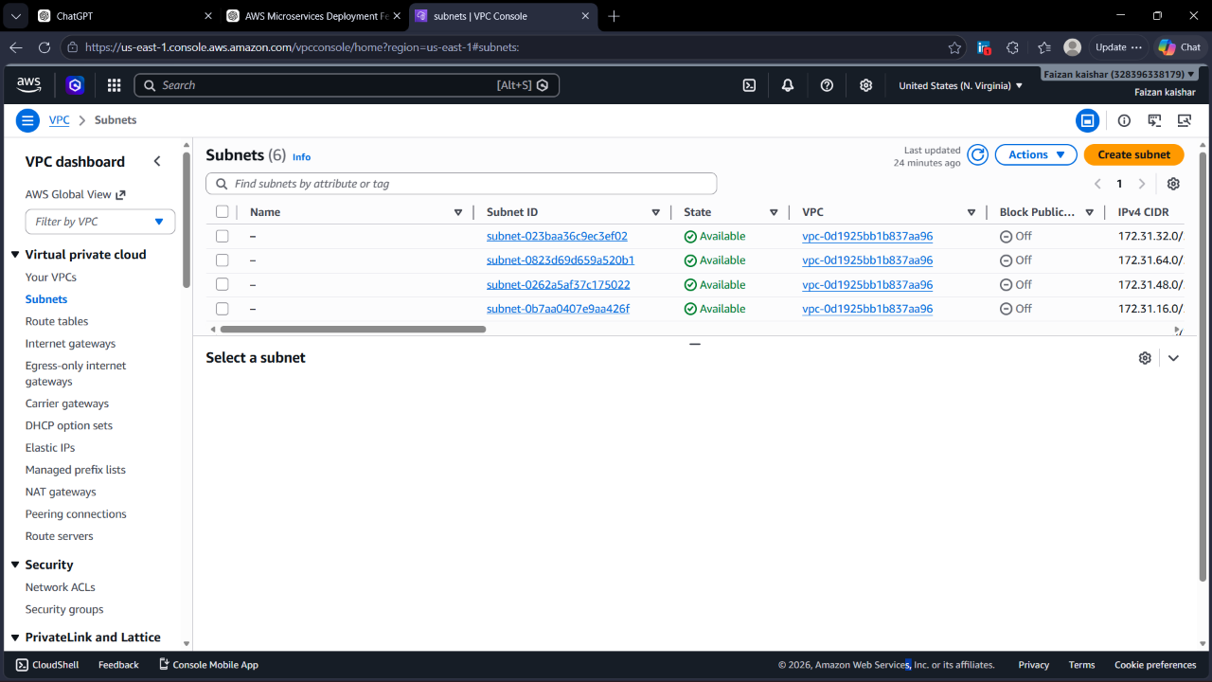

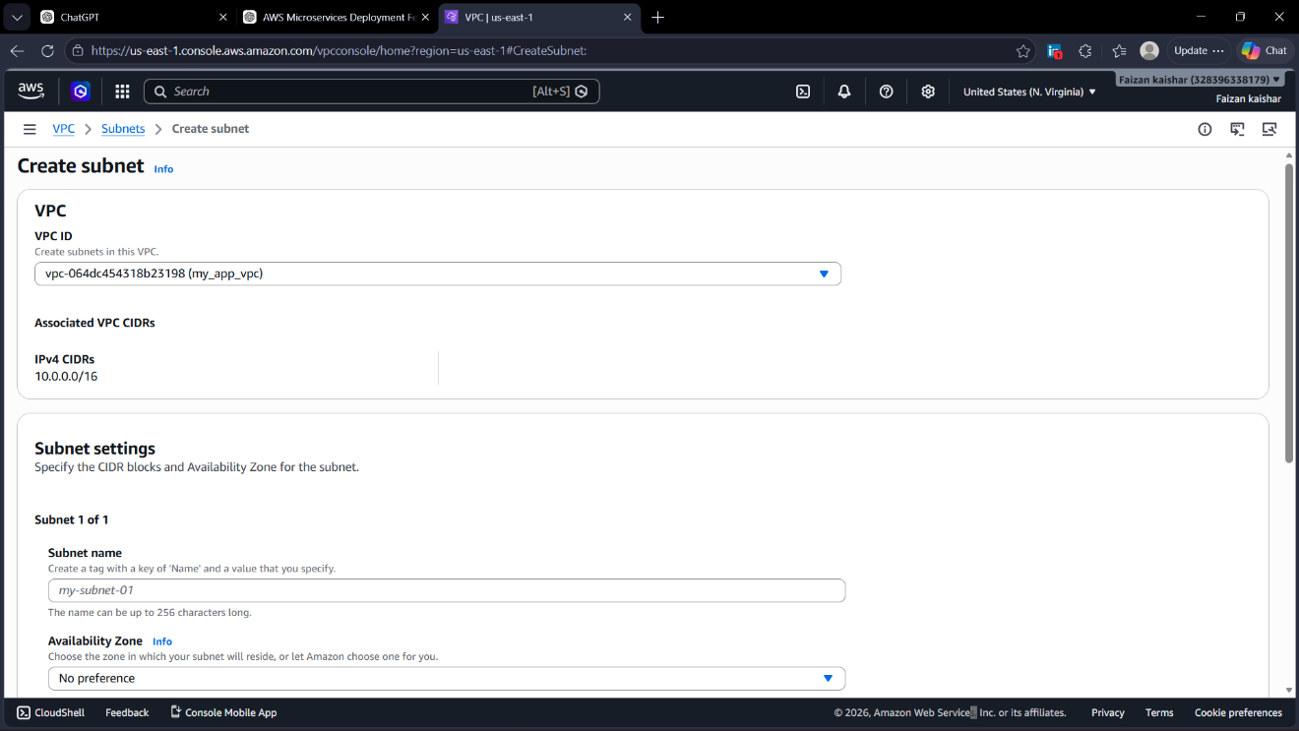

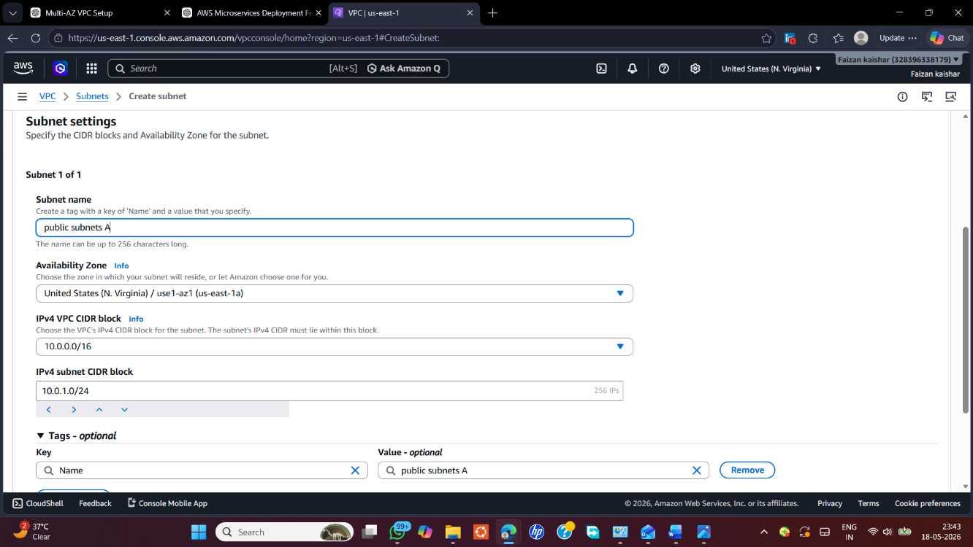
→ Public Subnet B

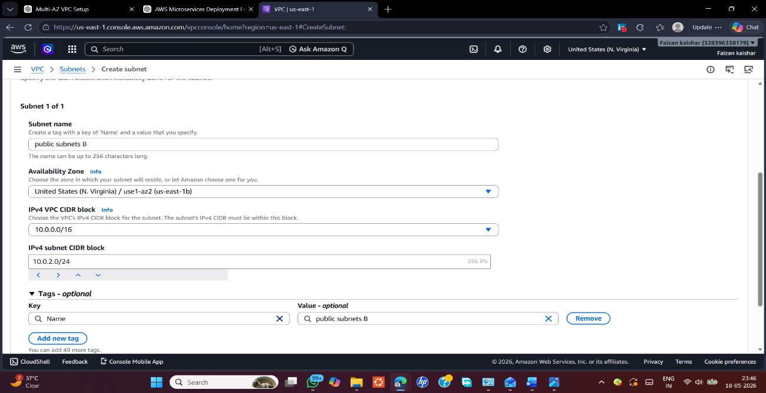

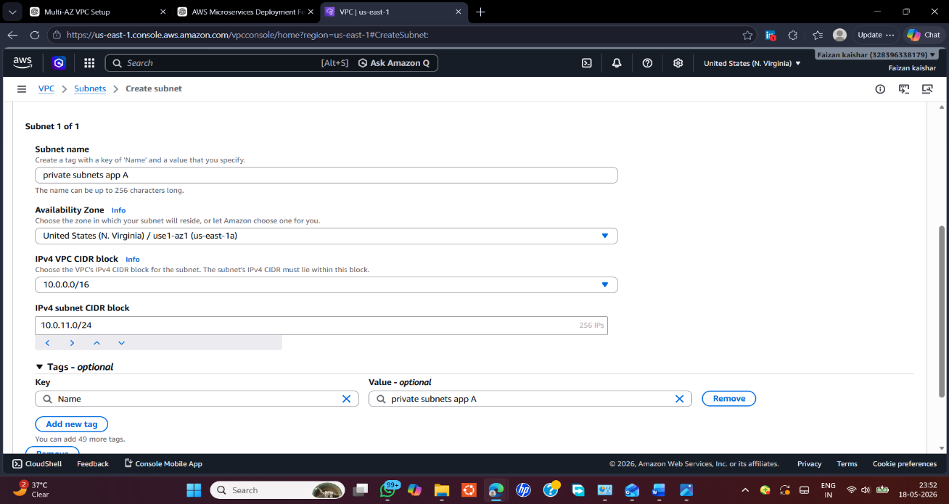
→ Private Subnet App A

→ Private Subnet App B
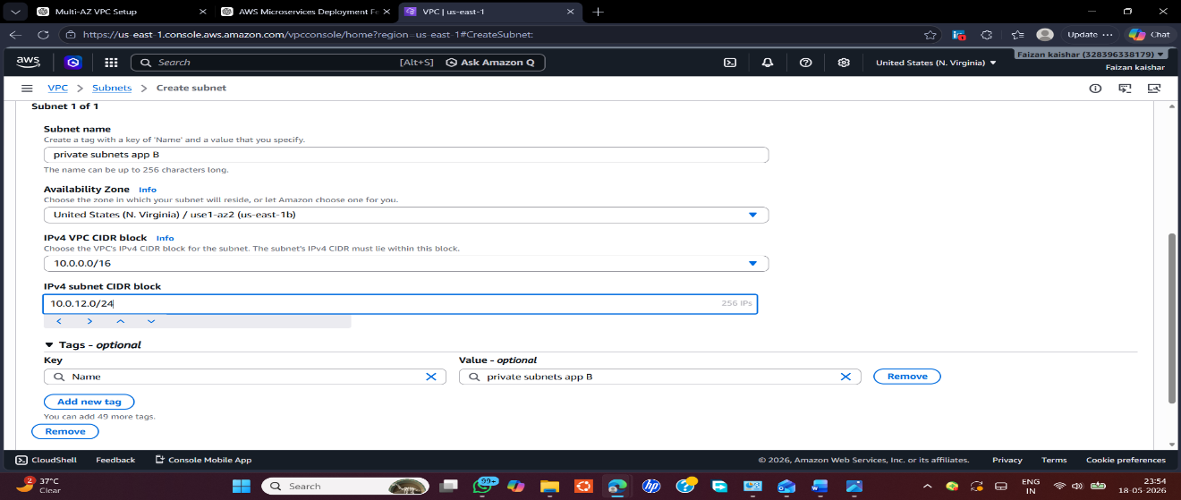

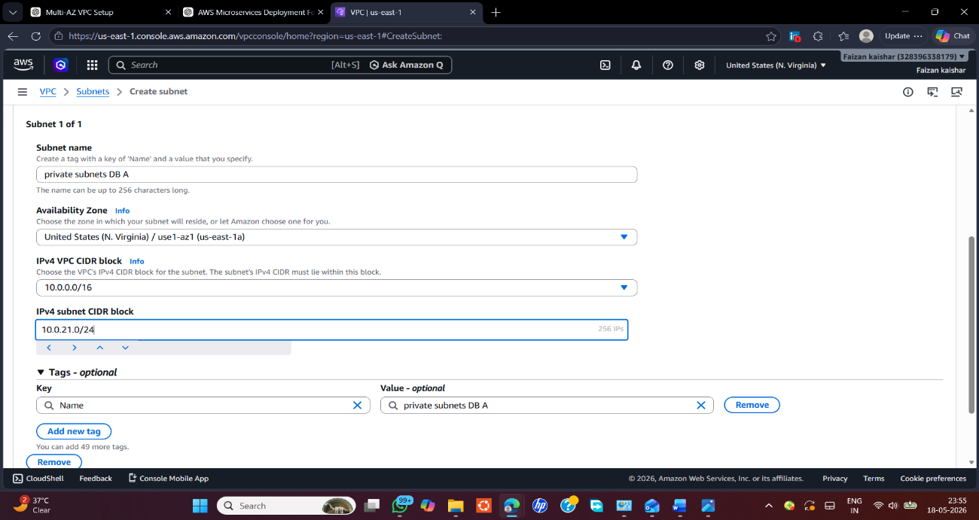
→ Private Subnet DB A

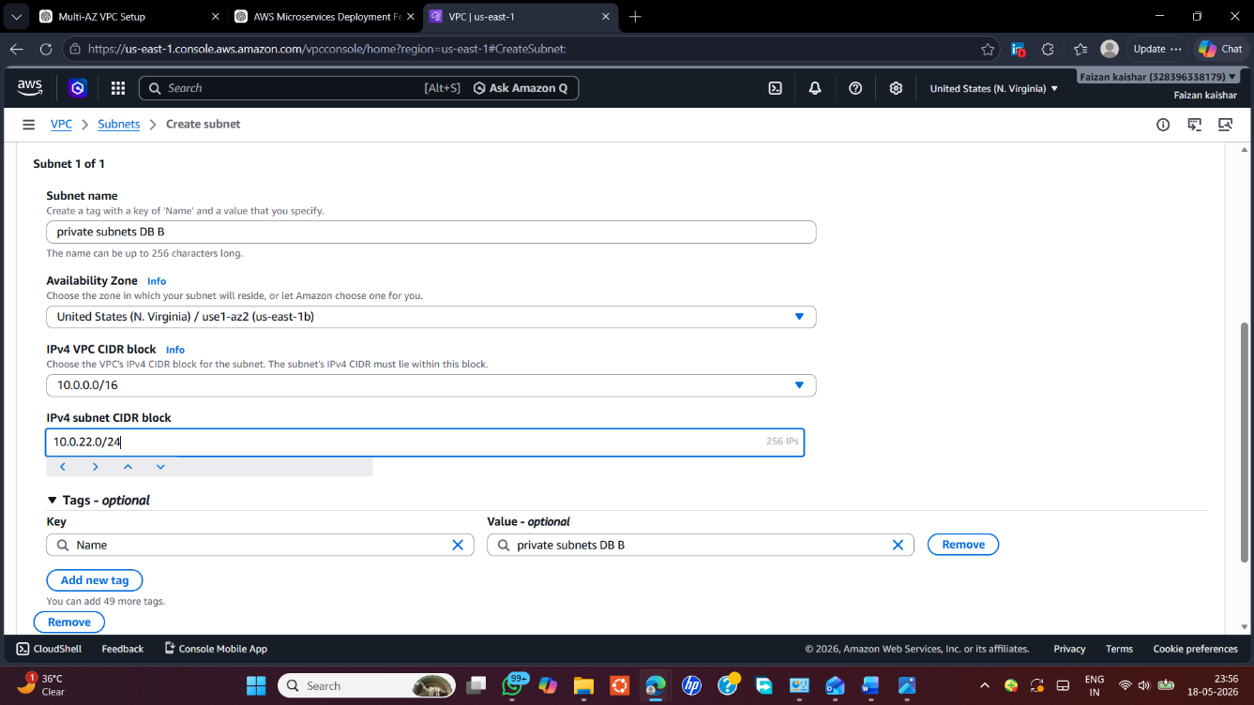
→ Private Subnet DB B

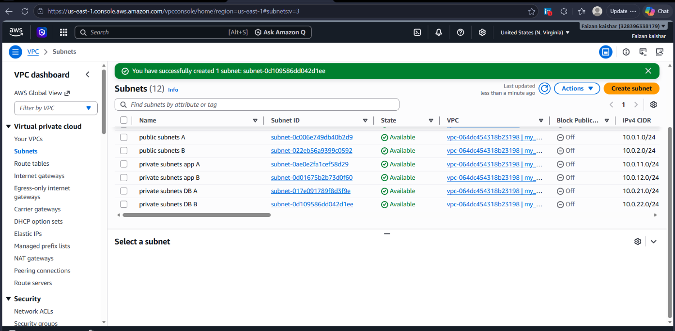

Step 3: Create Internet Gateway (IGW)
AWS Console → VPC → Internet Gateways → Create Internet Gateway → Name: igw →Click Create→ Then attach to VPC

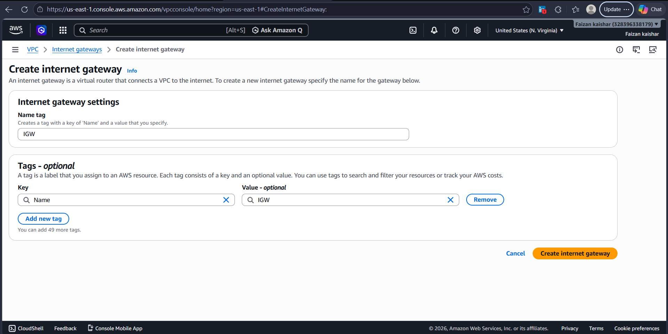

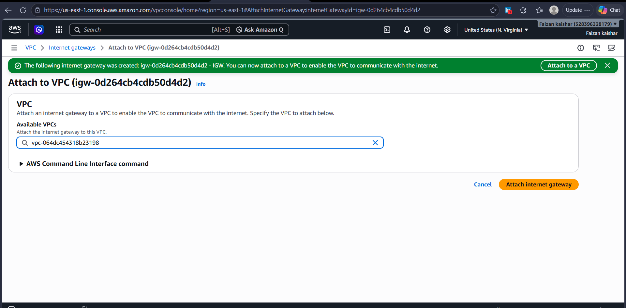

Step 4: Create NAT Gateway
Go:
VPC → NAT Gateways
Click: Create NAT Gateway
Fill: Name: nat-public-a
Subnet: public-subnet-a
Choose a Public subnet, not private.
Elastic IP:
Select: eipalloc-xxxx
Create
Wait ~1–3 minutes
Status: Available

Step 5: Optional Production Setup (Multi-AZ)
For high availability create another NAT:
Name: nat-public-b
Subnet: public-subnet-b
Allocate another Elastic IP
Create

Step 6: Create Public Route Table
Go:
VPC → Route Tables
Create:
Name: public-rt
VPC: microservices-vpc
Create

Step 7: Add Route to IGW
Open: public-rt
Routes → Edit routes
Add:
Destination | Target
0.0.0.0/0 | microservices-igw
Save
Meaning: All internet traffic → Internet Gateway

Step 8: Associate Public Subnets
Open: Subnet Associations
Edit
Select:
→ public-subnet-a
→ public-subnet-b
Save
Now:
public subnets
↓
public route table
↓
IGW
↓
Internet

Step 9: Create Private Route Table
Create:
Name: private-app-rt
VPC: microservices-vpc
Create

Step 10: Add NAT Route
Routes → Edit routes
Add:
Destination | Target
0.0.0.0/0 | nat-public-a
Save
This means: Private subnet outbound internet → NAT

Step 11: Associate App Subnets
Associate:
✅ private-app-a
✅ private-app-b
Save
Now ECS Fargate tasks can:
- pull images from ECR
- access GitHub APIs
- call external services
- install packages
But they still remain private.

Step 12: DB Route Table
Create:
private-db-rt
Associate:
→ private-db-a
→ private-db-b
Do not add an internet route.
DB should remain isolated.

Final routing:
public-subnet-a,b
↓
public-rt
↓
IGW
↓
Internet
private-app-a,b
↓
private-app-rt
↓
NAT Gateway
↓
Internet
private-db-a,b
↓
private-db-rt
↓
No internet access

→ Create NAT Gateway
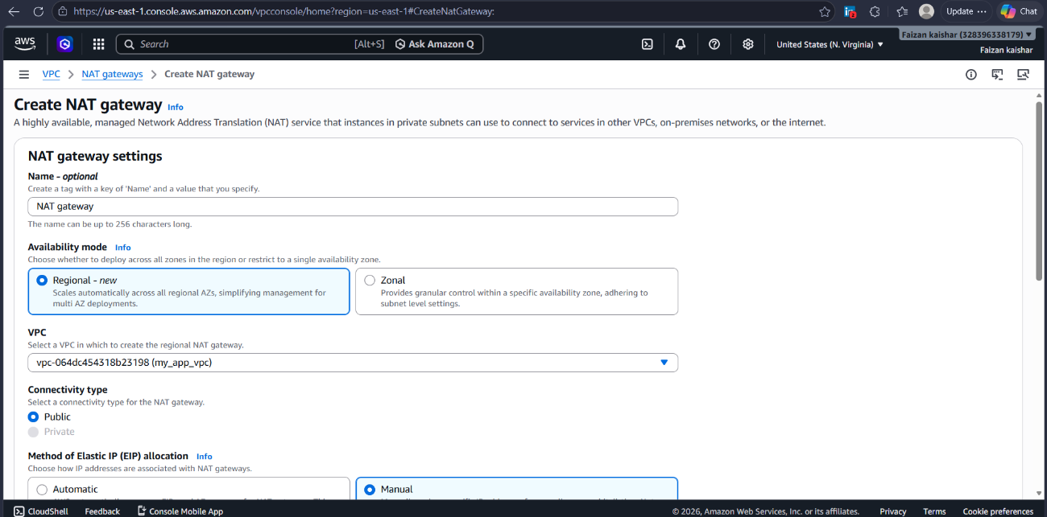

→ Route Table
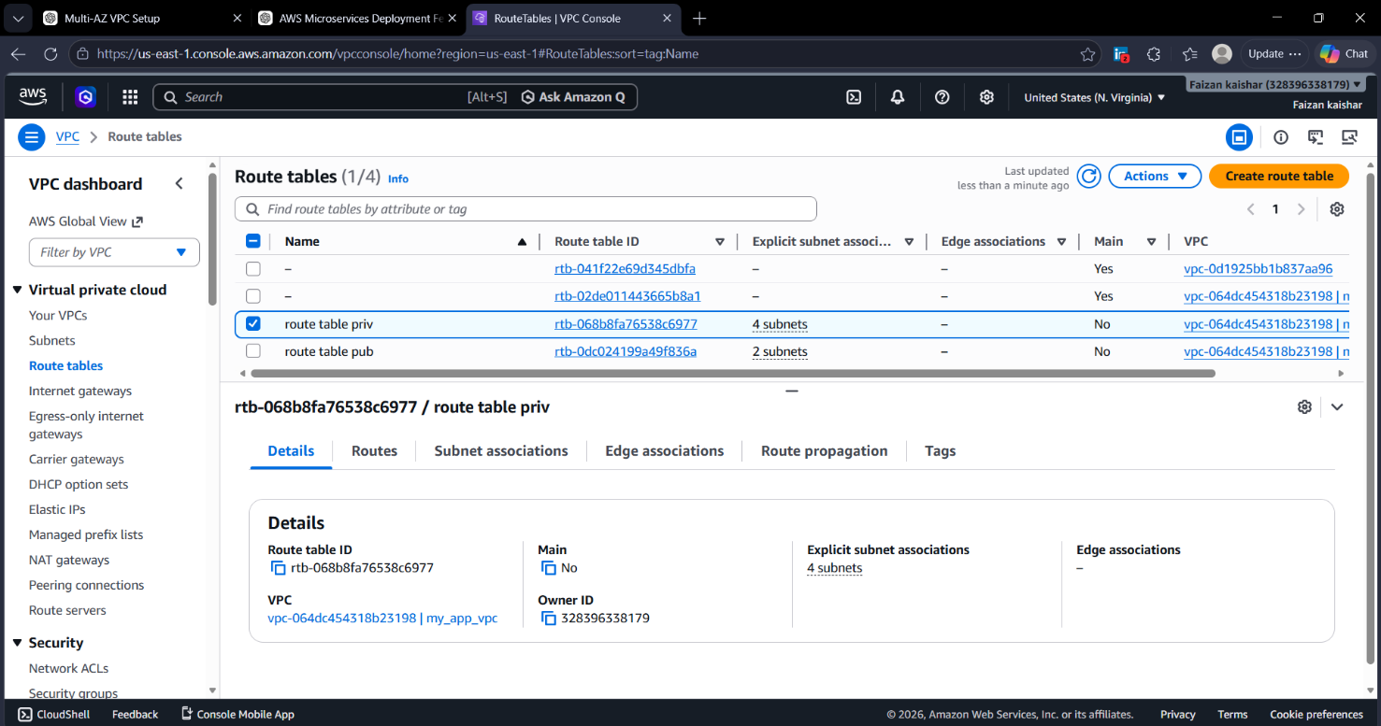

Next step: Application Load Balancer (ALB) + Security Groups for your ECS Fargate microservices.
Users
↓
HTTPS
↓
ALB (Public subnet)
↓
Security Group
↓
ECS Fargate (Private subnet)

Part 1: Create ALB Security Group
Open:
AWS Console → VPC → Security Groups
Click:
Create Security Group
Fill:
Name:
alb-sg
Description:
Security group for ALB
VPC:
microservices-vpc

Add Inbound Rules
Click Add Rule
Add:
Type | Port | Source
HTTP | 80 | 0.0.0.0/0
HTTPS | 443 | 0.0.0.0/0
Meaning:
- Internet users can access HTTP
- Internet users can access HTTPS

Outbound
Keep:
All Traffic → 0.0.0.0/0
Create security group
Result:
alb-sg

Part 2: Create ECS Security Group
Create another SG:
Name:
ecs-sg
Description:
Allow traffic only from ALB
VPC:
microservices-vpc

ECS Inbound Rules
Add:
Type | Port | Source
Custom TCP | 4001 | alb-sg
Custom TCP | 4002 | alb-sg
Source should be:
Security Group → alb-sg
Not:
0.0.0.0/0
This ensures:
Internet ❌ ECS
ALB → ECS ✅
Outbound:
Allow all
Create

Part 3: Create ALB
Open:
AWS Console → EC2 → Load Balancers
Again: this is only a management section; no EC2 instance is created.
Click:
Create Load Balancer
Select:
Application Load Balancer

Part 4: Basic Configuration
Enter:
Name:
microservices-alb
Scheme:
Internet-facing
IP type:
IPv4

Part 5: Network Mapping
Choose:
microservices-vpc
Select:
✅ public-subnet-a
✅ public-subnet-b
Do not select private subnets.
ALB should be in public subnets.

Part 6: Attach Security Group
Choose:
alb-sg
Remove default SG if attached.

Part 7: Listener Configuration
Add:
Protocol | Port
HTTP | 80
Later you'll add:
Protocol | Port
HTTPS | 443

Part 8: Create Target Group for Ingestion Service
During ALB creation:
Create new target group
Choose:
Target type = IP
Important:
For ECS Fargate always use:
IP
Do not choose:
Instance
Enter:
Name:
tg-ingestion
Protocol:
HTTP
Port:
4001
Health check:
/health
Create

Part 9: Create Retrieval Target Group
Create:
tg-retrieval
Port:
4002
Health:
/health

Part 10: Configure Listener Rules
Open:
ALB → Listeners → View/Edit Rules
Add:
Rule 1:
IF path = /api/upload/*
Forward:
tg-ingestion
Rule 2:
IF path = /api/search/*
Forward:
tg-retrieval
Save

Final traffic flow:
https://domain.com/api/upload
↓
ALB
↓
tg-ingestion
↓
ECS service 4001
https://domain.com/api/search
↓
ALB
↓
tg-retrieval
↓
ECS service 4002

AWS Microservices Deployment: ECR → ECS → Fargate → ALB

Architecture Flow
Developer
↓
Docker build
↓
ECR
↓
ECS Cluster
↓
Task Definition
↓
Fargate Service
↓
Target Group
↓
ALB

Step 1: Create ECR Repositories
ECR stores Docker images.
Open: AWS Console → Elastic Container Registry (ECR)
Click: Create Repository
Create repository:
Repository 1:
- Name: ingestion-service
- Visibility: Private
Repository 2:
- Name: retrieval-service
- Visibility: Private
Expected:
ingestion-service
retrieval-service

Step 2: Push Docker Images to ECR
Open repository: ingestion-service
Click: View Push Commands
Login:
aws ecr get-login-password --region ap-south-1 | docker login --username AWS --password-stdin ACCOUNT_ID.dkr.ecr.ap-south-1.amazonaws.com
Tag image:
docker tag ingestion:latest ACCOUNT_ID.dkr.ecr.ap-south-1.amazonaws.com/ingestion-service:latest
Push image:
docker push ACCOUNT_ID.dkr.ecr.ap-south-1.amazonaws.com/ingestion-service:latest
Repeat:
docker tag retrieval:latest ACCOUNT_ID.dkr.ecr.ap-south-1.amazonaws.com/retrieval-service:latest
docker push ACCOUNT_ID.dkr.ecr.ap-south-1.amazonaws.com/retrieval-service:latest
Verify images appear inside ECR.

Step 3: Create ECS Cluster
Open: AWS Console → ECS
Click: Create Cluster
Select:
- AWS Fargate
Cluster Name:
microservices-cluster
Infrastructure:
AWS Fargate
Create
No EC2 instances required.

Step 4: Create ECS Task Execution Role
Open: IAM → Roles → Create Role
Trusted Entity:
Elastic Container Service Task
Attach Policy:
AmazonECSTaskExecutionRolePolicy
Role Name:
ecsTaskExecutionRole
Purpose:
- Pull ECR images
- Send logs to CloudWatch

Step 5: Create Task Definition (Ingestion)
Open: ECS → Task Definitions → Create
Launch Type:
FARGATE
Task Name:
ingestion-task
Execution Role:
ecsTaskExecutionRole
CPU:
0.5 vCPU
Memory:
1 GB
Add Container:
Container Name:
ingestion-container
Image:
ACCOUNT_ID.dkr.ecr.ap-south-1.amazonaws.com/ingestion-service:latest
Port Mapping:
4001
Environment Variables:
DB_HOST=postgres-url
REDIS_HOST=redis-url
S3_BUCKET=mybucket
Logs:
awslogs
/ecs/ingestion
Create

Step 6: Create Retrieval Task
Task:
retrieval-task
Container:
retrieval-container
Image:
ACCOUNT_ID.dkr.ecr.ap-south-1.amazonaws.com/retrieval-service:latest
Port:
4002
CloudWatch:
/ecs/retrieval
Create

Step 7: Create ECS Ingestion Service
Open: Cluster → Create Service
Launch Type:
FARGATE
Task Definition:
ingestion-task
Service Name:
ingestion-service
Desired Tasks:
2
Network:
VPC:
microservices-vpc
Subnets:
- private-app-a
- private-app-b
Security Group:
ecs-sg
Assign Public IP:
DISABLED

Step 8: Attach ALB
Enable:
Application Load Balancer
Select:
microservices-alb
Container:
ingestion-container
Container Port:
4001
Target Group:
tg-ingestion
Create
ECS automatically registers task IPs.

Step 9: Create Retrieval Service
Task:
retrieval-task
Service:
retrieval-service
Subnets:
- private-app-a
- private-app-b
Target Group:
tg-retrieval
Port:
4002
Create

Step 10: Verify Targets
Open: EC2 → Target Groups
Check:
tg-ingestion
Targets:
Healthy
Repeat:
tg-retrieval
Expected:
Healthy

